**Applicant:** Dr. Elizabeth Hughes

**Primary Supervisor:** Dr. Edward Wallace

**Secondary Supervisor:** Dr. Elizabeth Bayne

**Host Organization:** Institute for Cell Biology, School of Biological Sciences, University of Edinburgh.

**Project Title:**  Dynamic mRNA processing in response to environmental stimuli in the fungal pathogen *Cryptococcus neoformans*.

1. **Reasons for applying for a fellowship**

I am a skilled and highly motivated molecular biologist with 10 years lab-based experience, 6 post-doctoral. In order to succeed in the current job market, I need to update my skillset and access the rapidly advancing technologies and evolving practices in my field.

My PhD investigated the relationship of HIV viral populations and disease progression via evolutionary analysis of isolates infecting lymphoid and non-lymphoid tissues 1,2. My first author paper reported the discovery of a previously unknown dormant HIV population in the brain and has over 100 citations to date. 1 As a post-doc, I examined Hepatitis C Virus replicative processes by investigating a non-structural protein (NS5B) implicated in RNA-dependent-RNA-polymerase activity. I optimized bacterial expression systems and purified this protein. I also investigated the structure/function of major-outer-membrane-proteins of *Chlamydia trachomatis* and *psittaci* where I cloned and expressed wild-type and mutated proteins and functionally reconstituted them at the single-channel level.3 I then joined a leading bio-safety testing facility, BioReliance, as the research and development scientist and developed a wide range of molecular based assays for clients while also providing technical training/support for colleagues.

I took a career break at the end of April 2004 when my daughter was 18 months old to raise my family. My husband works in the marine industry as a consultant which regularly takes him away from home for extended periods of time. Due to this and prohibitive childcare costs we decided I would put my career on hold and take on the administrative side of my husband’s business. During this time I have been an active member of primary and secondary school councils and have volunteered as a teacher’s assistant at Lanark Primary School for general science and as a group leader for cub pack holidays and weekly meetings for cubs and scouts. I have been an active fundraiser through school parent councils and local youth groups. My children (16 and 13 years) now attend high school and I feel it is the right time for me to return to my chosen career.

After applying for numerous positions I learned of the Daphne Jackson career re-entry Fellowship from my supervisor Dr. Wallace. This is an ideal platform for me to resume my career because the emphasis is on improving employability through updating existing, and gaining new skills. This fellowship will enable me to become competitive in the highly skilled molecular biology field while still caring for my family. I will gain valuable expertise in new routine technologies such as RNA-seq, which have been developed during my career break, and forging relationships with prospective employers and mentors to ensure the success of my career.

Word count: 437/400

1. **How can an environmental fungus, *Cryptococcus neoformans*, adapt to cause disease in humans?**

*Cryptococcus neoformans* lives in the environment growing on trees, pigeon droppings and in the soil. It infects people when they breathe it into their lungs (see figure 1). Infection is rare in healthy people and most cases occur in people with a weakened immune system (cancer treatment patients or HIV). In the lung it causes a pneumonia-like-illness but it can spread to the brain causing life-threatening meningitis. Approximately 1 million cases occur globally each year resulting in estimated deaths of 600,000.

How does *C. neoformans* adapt to the rapid change in environment from soil/vegetation to a mammalian lung? I will examine what changes occur in this fungus when it reactivates in a host-like environment and identify observable characteristics under different environmental conditions. I will look at the changes in the amount/type of genes that are switched on/off during exposure to these conditions. Measuring gene activity can tell us a lot about how an organism responds to its environment.

Once *C. neoformans* has entered the lung it will encounter a number of microbes, some of which may influence its ability to cause disease. Fragments from bacterial cell walls induce ‘Titanization’ (changes in Cryptococcus size) which is important for infection. It is not known how the fungus responds in this way or indeed how fungi in general detect and respond to nearby bacteria. I will assess the impact bacterial cell wall fragments have on the ability of Cryptococcus to adapt to a new environment by observing changes in the characteristics and gene expression of each fungal strain.

Identifying unique or critical pathways Cryptococcus uses to cause disease will provide unique targets for drug design. I will document any changes in Cryptococcus during reactivation in different environmental conditions and study the pathways by mutating identified critical fungal genes and examining the different behaviors of these mutant stains during reactivation.

Fungal infections are one of the hardest diseases to manage in humans. Most infect people with underlying problems and jeopardize medical advances in cancer care and organ transplant because the immune system is weakened. With 600,000 deaths caused by *C. neoformans* infections world-wide a concerted effort is needed to work out how this organism can change to grow in our lungs and spread through our bodies, avoiding all our defenses, to cause disease.

Word count: 379/350

**4. Abstract**

How does *C. neoformans* adapt to the lung environment? Transformation from spores/desiccated yeast into actively replicating cells must be associated with dynamic regulation of mRNA and hence gene expression. This proposal will build on preliminary data from Dr. Wallace/Dr. Ballou showing the addition of serum to media causes a radically different response in phenotype/RNA abundance during reactivation and a distinct morphological change from a normal yeast to a titan cell, replicated using purified muramyl dipeptide. It is not known which component(s) in the media gave rise to such differences/changes. The goal of this proposal is to investigate how *C. neoformans* adapts to the lung environment by analyzing what serum component(s) trigger an acute stress response, investigating how bacterial cell wall components influence gene expression, and identifying essential genes and biological function. To achieve this goal *in vitro* culture models will be employed to dissect distinct stimuli and analyze differential-gene-expression (RNA-seq)/function (CRISPR) to provide a snapshot of cellular metabolism providing insights for novel therapeutic methods.

Word Count: 164/150

**5. Host Organization**

As one of the UK’s leading research facilities the University of Edinburgh provides a state-of-the-art environment for research. It is ranked 18th in the world, 4th in the UK and the top university in Scotland. This was reaffirmed by the results of the 2014 Research Excellence Framework placing this University as Scotland’s top-ranked research institution. The University of Edinburgh is a member of the SWAN charter and won its first Athena Swan Institutional Bronze Award in 2006 and has just renewed its Silver Award in 2018. The University of Edinburgh has also signed the national Concordat to support the career development of researchers. This document lays out 7 principles to increase the sustainability of research careers in the UK and to improve the quality, quantity and impact of research in society.

The Centre for Synthetic and Systems Biology, in the Institute for Cell Biology, is a unique inter-disciplinary environment with a track record for multi-disciplinary research. I will be joining the Wallace lab in this centre. Dr. Wallace is a new principal investigator at the University of Edinburgh, having established his lab in early 2018, consisting of Dr. Rosey Bayne (PDRA/Lab manager), Dr. Laura Tuck (PDRA) and Samuel Haynes (PhD student). The centre includes the Edinburgh Genome Foundry (a world class facility for automated DNA design and assembly) and EdinOmics providing expertise in quantitative biochemistry including up-scaling and automation of RT-qPCR. There are facilities for cell imaging (LEAP and single cell analysis and microscopy groups) and for innovative data analysis and mechanistic modelling.

My primary supervisor, Dr. Wallace, is a quantitative biologist specializing in fungal RNA processing. My secondary supervisor, Dr. E Bayne, specializes in endogenous RNA interference pathways and is using Cryptococcus as a eukaryotic model. Working with my supervisors will allow me to build on my existing skills in the field of molecular biology whilst learning new techniques including medium throughput RT-qPCR, cDNA library preparation and high throughput sequencing (RNA-seq), lab automation, genome editing (CRISPR), bioinformatics, and working with large data sets. This will provide me with crucial work experience in one of Scotland’s world-class universities and equip me with specific skills in high demand in biomedical research and biotechnology industries.

My collaborator, Dr. Ballou, is an expert in *C. neoformans* biology, including relevant culture conditions and models of host-pathogen interaction required for this proposal. I will spend some time shadowing in the Ballou lab to learn these techniques. Dr. Ballou will contribute advice, training and support my professional development.

Dr. R Bayne has 30 years of experience in molecular biology techniques and will take a lead role in my technical/lab based training along-side Dr. Tuck.

Table 1: Supervisors and Collaborators

|  |  |  |  |
| --- | --- | --- | --- |
|  | Name | Institute | Position |
| Primary Supervisor | Dr. Edward Wallace | The University of Edinburgh | Sir Henry Dale Fellow (Wellcome Trust/Royal Society Early Career Research Fellow).  Institute for Cell Biology, School of Biological Sciences |
| Secondary Supervisor | Dr. Elizabeth Bayne | The University of Edinburgh | Reader in Epigenetics, School of Biological Sciences, |
| Collaborators | Dr. Elizabeth Ballou | University of Birmingham | Sir Henry Dale Fellow and Lecturer.  Institute for Microbiology and Infection, School of Biosciences |

Word Count: 438/400**6. Retraining Program**

**6.1: Technical Skills**

In order to carry out the proposed aims of my fellowship I will vastly expand my knowledge of new exciting techniques like RNA-seq and CRISPR while updating existing ones such as qPCR. Learning large scale data set production and analysis will be vital for this project. The ability to handle and analyze large data sets is becoming an imperative skill in modern biomedical science.

Table 2a: New and Refreshed Technical Skills

|  |  |  |
| --- | --- | --- |
| Training |  |  |
| New Skills | Method | Trainor/Course |
| How to culture and extract RNA from Cryptococcus | 1-1 | Dr. R Bayne/Dr. Ballou |
| How to identify and phenotype Cryptococcus using various microscopic techniques and stains | Course/1-1 | The Wellcome Centre Microscopy Course run by Dr. Kelly at the University of Edinburgh/Dr. Ballou |
| Lab automation to enable processing of large numbers of RT-qPCR | 1-1 | 1-1 at the Edinburgh Genome Foundry in the University of Edinburgh |
| RNA-Seq | 1-1 | Dr. R Bayne and Dr. Wallace |
| Bio-Informatics to analyze the large data sets produced | Course/1-1 | Bioinformatics for Genomics, a 5 day workshop run at the Edinburgh Genomics Centre (£750)/Dr. Wallace |
| CRISPR-Cas 9 system | 1-1 | Dr. R Bayne, Dr. Tuck |
| Refreshed Skills |  |  |
| Aseptic technique | 1-1 | Dr. R Bayne |
| RNA manipulation | 1-1 | Dr. R Bayne |
| RT-qPCR | 1-1 | Dr. R Bayne and Dr. Wallace |

This fellowship will increase my employability by bridging my skills gap using a framework for structured training of relevant skills in demand in today’s job market. I will train under the guidance of Dr. Wallace, Dr. E Bayne, Dr. Ballou, Dr. R Bayne and Dr. Tuck who are proficient in all the necessary techniques and are committed to supporting me and my endeavor to return to the workforce.

**6.2: Professional Skills/Development**

During this fellowship I will have access to 3 training courses from the Daphne Jackson Trust covering professional skills, how to publish and how to improve your confidence. This provides an excellent opportunity for me to develop as a researcher and also as a person. Having been away from science for a number of years, building confidence in myself and my ability is very important. The Institute for Academic Development at the University of Edinburgh is a facility providing many opportunities for education and professional development. The available program provides workshops and courses on academic writing, career management and development, data management, funding opportunities, ethics, teaching and supervising students. During my fellowship I will use these resources to enhance my professional qualifications/development. Within the Institute for Cell Biology there is also a dynamic seminar series covering a wide range of topics from internal and external speakers.

Table 2b: Personal/Professional Development Opportunities

|  |  |  |
| --- | --- | --- |
| Course | Method | Provider |
| Professional skills | Workshop | Daphne Jackson Trust |
| How to publish | Workshop | Daphne Jackson Trust |
| How to improve your confidence | Workshop | Daphne Jackson Trust |
| Finding funding for research | Online | IAD* |
| Get that paper written and published | Workshop | IAD* |
| Managing your research data | Workshop | IAD* |
| Writing research proposals for the college of science and engineering | Workshop | IAD* |
| Attracting your own research funding | Workshop | IAD* |
| Be better than boring bullet points: giving a great presentation | Workshop | IAD* |
| Academic CVs | Workshop | IAD* |
| Effective collaborations | Workshop | IAD* |
| Practical project management for researchers | Workshop | IAD* |
| Professional networking, engaging and strategy | Workshop | IAD* |
| Project management (research) | Workshop | IAD* |
| Spotlight on…Co-supervision | Workshop | IAD* |
| Time management | Workshop | IAD* |

*The Institute for Academic Development at the University of Edinburgh

During my training I will attend relevant conferences as these provide a national/international platform for sharing information and ideas and keeping up to date with the latest innovations and advancements. This will allow me to present my work and show what skills I have learnt and network with other research groups. Some upcoming conferences within the field of mycology are:

* British Society for Medical Mycology, Annual.
* FEBS Advanced Lecture Course in Human Fungal Pathogens, Biennial.
* 6th International Conference on Mycology and Fungal Infections, Oct 2019, UAE.
* 11th International Conference on Cryptococcus and Cryptococcosis, 2020, Uganda.
* International Society for Human and Animal Mycology, March 2021, India.

Word Count: 389/400

Table 2c: Re-Training Program Summary

|  |  |  |  |  |  |  |
| --- | --- | --- | --- | --- | --- | --- |
| Skill | Methods | Refresh  skills | New  skills | Month | Base* | Objective |
| Cell Culture Techniques | Culture preparation/storage | ✓ | ✓ | 1-4 | LB | Refresh knowledge and apply to fungal cells to test the effect different environmental stimuli have on the morphology of Cryptococcal cells, correlate with gene expression. |
| Sub culturing/cell-maintenance | ✓ | ✓ |
| Aseptic technique | ✓ | ✓ |
| Microscopic Techniques | Visualization/fixing/staining of fungal cells | ✓ | ✓ | 1-4 | LB | Identify morphological changes in cultured yeast cells grown in the presence of different environmental stimuli. |
| RNA Manipulation | QIAgen plant and fungal RNA extraction kit |  | ✓ | 3-6 | LB | Gain experience in using up-to-date techniques for the isolation of RNA from fungal cells. |
| Assess RNA quality/quantity, Agilent bioanalyzer | ✓ | ✓ |
| RT-qPCR | Primer design/validation | ✓ |  | 5-12 | LB | SYBR-Green fluorescence based qPCR to analyse gene expression in response to environmental stimuli to provide a deeper understanding of the molecular mechanisms underpinning physiological change. |
| RT-qPCR | ✓ | ✓ |
| cDNA synthesis | ✓ |  |
| Data analysis |  | ✓ | 7-14 | CB |
| Lab Automation | RT-qPCR using 384/1536-well plates |  | ✓ | 5-12 | LB | Training in automatic plate loading at Edinburgh Genome Foundry |
| Next Generation  Sequencing | RNA-seq |  | ✓ | 13-22 | LB | Illumina sequencing with cDNA libraries to quantify the dynamic expression levels in yeast cells under variable conditions. This technique also enables novel RNA's to be discovered. |
| Data analysis |  | ✓ | 13-22 | CB |
| Bio-Informatics | R-Programming |  | ✓ | 1-36 | CB | Use R to analyse RT-qPCR and DESeq2 to analyse RNA-seq data. As required additional analytical methods will be employed. |
| Handling/analysis of large data sets |  | ✓ | Continuous | CB |
| CRISPR-Cas9 system | Functional analysis of genes |  | ✓ | 18-24 | LB | Knock out genes of interest for functional characterization. |
| Personal Development | Attend courses | ✓ | ✓ | Continuous | TBD | Gain valuable transferrable skills for further development of my career and to secure further funding or employment following this fellowship. |
| Attend Seminars/  Conferences | Expand knowledge base |  | ✓ | Continuous | TBD | Network with other scientists to share my research/initiate future possible collaborations. |
| Meetings with Sponsor | Discuss research project and progress |  | ✓ | Bi-annual | OB | Discuss progression of project and training enabling me to keep on track. Implement new training strategies where applicable. |
| Progression Milestones | Reports/publications |  | ✓ | Annual | OB | Provide yearly reports on progression of project and publish results in peer reviewed journals. |

*LB-Lab based, OB- Office Based, CB- Computer based, TBD-To be decided

1. **Dynamic mRNA processing in response to environmental stimuli in the fungal pathogen *Cryptococcus neoformans*.**

**Background:**

*C. neoformans* is an opportunistic facultative saprophyte and an important global human pathogen4,5. *C. neoformans* primarily infects immunocompromised individuals, who will have an abnormal lung microbiome, and is one of only a few fungal species that have been shown to cross the blood-brain barrier leading to cryptococcal meningitis that is fatal if left untreated 4,5. The onset of the AIDS epidemic in the 1980s was accompanied by a surge in cryptococcosis cases world-wide. Antiretroviral therapy and antifungals have reduced the number of fatal cryptococcal meningitis cases, however, it remains a serious concern for the immunocompromised and is a major problem in resource-limited countries, where HIV prevalence is high, and access to health care and appropriate drug regimens is limited. A global number of almost 1 million cases of cryptococcal meningitis are estimated to occur with more than 600,000 resulting deaths.4,6 Cryptococcus is prevalent in the environment world-wide and over 70% of cases occur in sub-Saharan Africa. However, an outbreak of *Cryptococcus gattii* in immunocompetent individuals has been reported in North America7–9 and 2 patients in Glasgow were infected and with Cryptococcus in late 2018 where one patient died as a result.

The long-term disease progression of *C. neoformans* is beginning to be characterized, however, there is very little understanding of the early stages of infection. *C. neoformans* is found in the environment typically associated with pigeon guano, soil and decaying wood. It is a free living fungus with no requirement for a mammalian host, however, it is able to adapt, survive and proliferate within mammals to cause disease. Inhalation of spore/desiccated yeast cells are postulated to act as infectious propagules as only particles smaller than 5µm in diameter can reach the alveoli. *C. neoformans* must undergo rapid changes in gene expression to adapt to the alien environment/lung microbiome and its ability to alter its transcriptome in response to different environmental stimuli will ensure its survival in different host niches. Indeed, there is at least 1.5 million known fungal species with only 0.2% able to cause human disease. Few fungal species are thermotolerant at temperatures above 35⁰C , a characteristic virulence factor of *C. neoformans* and consistent with its role as a human pathogen10.

I will examine what happens when this organism reactivates within this alien environment by measuring differential gene expression under different conditions and relating this to crucial virulence factors, including capsule production. Measuring changes in gene expression provides a snapshot of what is happening inside the cell and by doing this over a time course we can follow the metabolic activity within a cell and essentially see what it is planning. We can then formulate a hypothesis on the adaptive response/responses required for this accidental pathogen to survive.

By combining bioinformatics and experimental investigation essential genes can be identified and putative proteins can be characterized. However, knowledge of the mRNA expression pattern alone does not necessarily indicate protein function and therefore must be experimentally verified. I will apply the CRISPR-Cas9 system to functionally characterize critical genes of interest. A deep understanding of the transcriptome and gene function in Cryptococcus may elucidate potential targets for drug design. New anti-fungal treatments are badly needed as the current therapies were developed over 50 years ago. This will require a greater understanding of the basic biology and virulence mechanisms of this fungus and how it can adapt/evolve into a well-established human pathogen.

Figure 1: *Cryptococcus neoformans* life cycle: Saprophyte verses Pathogen

|  |  |
| --- | --- |
| In the Environment: Saprophyte | In the Host: Pathogen |
| C:\Users\Elizabeth\Documents\Edward Wallace\DJTF proposal\Life cycle images\arrow 2.PNGC:\Users\Elizabeth\Documents\Edward Wallace\DJTF proposal\Life cycle images\spore dispersal.PNGC:\Users\Elizabeth\Documents\Edward Wallace\DJTF proposal\Life cycle images\arrow 2.PNGC:\Users\Elizabeth\Documents\Edward Wallace\DJTF proposal\Life cycle images\arrow 2.PNGC:\Users\Elizabeth\Documents\Edward Wallace\DJTF proposal\Life cycle images\cell fusion.PNGC:\Users\Elizabeth\Documents\Edward Wallace\DJTF proposal\Life cycle images\nuclear fusion.PNGC:\Users\Elizabeth\Documents\Edward Wallace\DJTF proposal\Life cycle images\arrow 2.PNGC:\Users\Elizabeth\Documents\Edward Wallace\DJTF proposal\Life cycle images\spore formation.PNGC:\Users\Elizabeth\Documents\Edward Wallace\DJTF proposal\Life cycle images\sex bodies.PNGC:\Users\Elizabeth\Documents\Edward Wallace\DJTF proposal\Life cycle images\arrow 2.PNGC:\Users\Elizabeth\Documents\Edward Wallace\DJTF proposal\Life cycle images\Amoeba.PNG  Environmental amoeba  Basidium formation  Mitosis  Spores/desiccated yeast cell dispersal  Cryptococcal mating types  Cell fusion | C:\Users\Elizabeth\Documents\Edward Wallace\DJTF proposal\Life cycle images\arrow 2.PNGC:\Users\Elizabeth\Documents\Edward Wallace\DJTF proposal\Life cycle images\blood vessel.PNGC:\Users\Elizabeth\Documents\Edward Wallace\DJTF proposal\Life cycle images\arrow 2.PNGC:\Users\Elizabeth\Documents\Edward Wallace\DJTF proposal\Life cycle images\brain 2.PNGC:\Users\Elizabeth\Documents\Edward Wallace\DJTF proposal\Life cycle images\arrow 2.PNGC:\Users\Elizabeth\Documents\Edward Wallace\DJTF proposal\Life cycle images\figure.PNG  Deposit in the alveoli  Breath in propagules  Dissemination through the blood stream  Acapsular  Infect brain tissue causing Cryptococcal meningitis  Capsule induction  Budding yeast  Cross Blood-Brain Barrier |

**Aim 1: What environmental stimuli in the host trigger an acute stress response in *C. neoformans*?**

Previous investigations carried out by Dr. Wallace and Dr. Ballou, to dissect the contributions of host factors and temperature in shaping initial growth, found a distinct physiological response (capsule induction) and differential RNA abundance between different growth conditions (see Fig. 2-4). Different capsule phenotypes have been observed in different organs and *C. neoformans* can modify the size and structure of its capsule in response to environmental stimuli suggesting plasticity of the capsule is of biological importance.

Current knowledge of the early events in *C. neoformans* infections are based on research using animal models or *in vitro* culture methods, primarily in rich fungal support media such as YPD during log phase growth. While these methods have produced useful data they do not accurately reflect the deposition of desiccated yeast into the lung environment, where nutrients are likely to be scarce.

The reactivation of Cryptococcus is radically different in rich media compared to cell culture media containing serum suggesting host-like media/serum induces capsule production. However, we do not know which component(s) give rise to this phenotypic change or which pathways are responsible. I will address this gap in knowledge by using well defined media and measuring the transcriptome response of Cryptococcus.

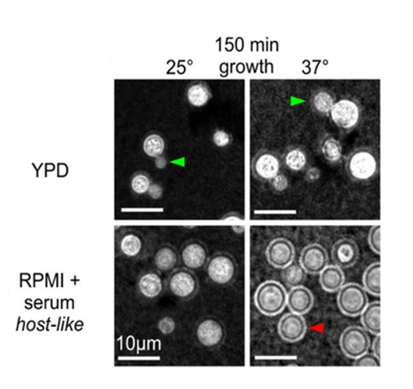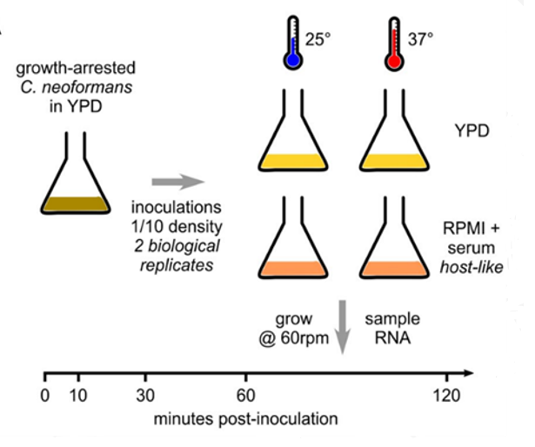

Figure 3: Micrograph with India ink staining 150 min after inoculation. Budding (green arrow) in YPD. Capsule induction (red arrow) in RPMI at 37⁰C

Figure 2: RNA time course to measure the contribution of nutrient and temperature to initial growth.

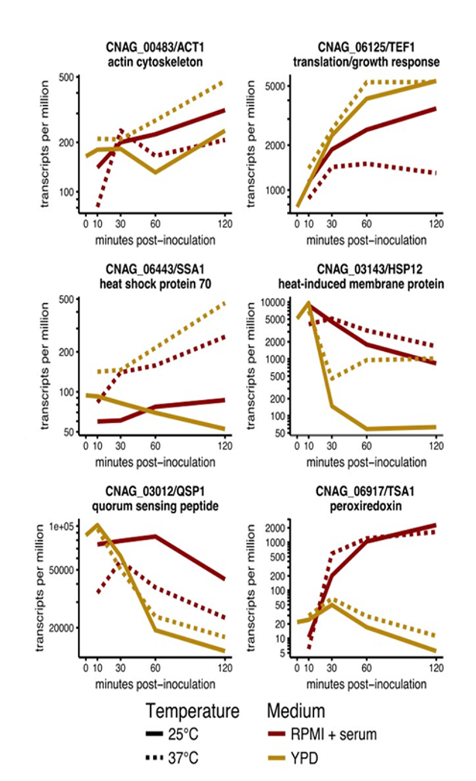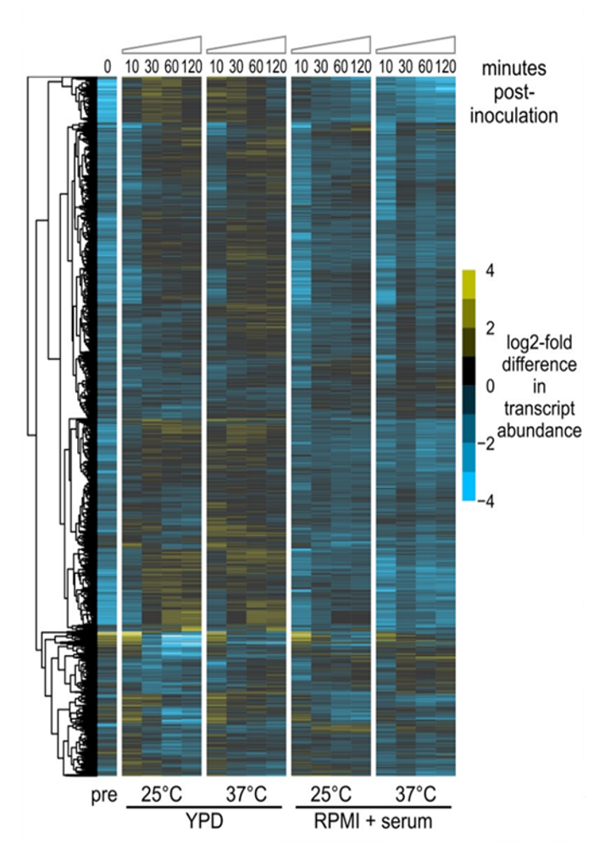

Figure 5: Select genes showing differential regulation of RNA abundance (transcripts/million), log2 mean of 2 biological replicates.

Figure 4: Heat map shows log2 of the difference from median abundance (transcripts/million) for each RNA, log2 mean of 2 biological replicates.

**Objective:**

In the first 4 months I will retrain in cell culture and microscopy techniques and apply this to growing and identifying yeast cell morphologies. In months 3-12 I will learn how to extract RNA from yeast cells using the QIAgen-plant-and-fungal-RNA-extraction-kit and will identify what causes this phenotypic shift by analyzing differential gene expression using RT-qPCR. I will also be trained in lab automation at the genome foundry to enable me to upscale the RT-qPCR, necessary for the combinatorial dissection of multiple media components. This will highlight the important early steps for adaptation to the lung environment and will provide me with an opportunity to further develop my molecular and microbiology skillsets. I will be trained how to use R to analyze large data sets produced in the second half of my first year.

**Method:**

To determine whether the phenotypic change is due to serum or host-like media in the above experiment I will inoculate growth-arrested *C. neoformans* yeast cells grown in YPD (GA-Cn-YPD) into RPMI-1640 media and YPD + serum and incubate at 25⁰C and 37⁰C. I will determine any phenotypic changes (India ink stain for capsule induction) and extract RNA for analysis using RT-qPCR (verified primers against differentially expressed genes previously detected by RNA-seq in the Wallace lab). I will compare alterations in the gene profile in relation to phenotype.

Serum induces capsule production in Cryptococcus11 but it is unknown which component(s) of serum (a key host-relevant stimulus) is responsible. Although it is routinely used in cell culture, it is a highly variable and undefined component with a complex composition that is still not fully understood. I will dissect the component(s) in serum responsible for capsule induction by incubating GA-Cn-YPD in RPMI-1640 + purified albumin (major component) and RPMI-1640 + charcoal stripped FBS (CS-FBS: reduced levels of endotoxins and hormones; see table 3a below).

Table 3a: Dissection of Serum Components

|  |  |  |  |  |  |  |
| --- | --- | --- | --- | --- | --- | --- |
| Media | No Serum (Serum starvation) | FBS | Charcoal stripped FBS | Albumin | 25⁰C | 37⁰C |
| RPMI-1640 | ✓ |  |  |  | ✓ | ✓ |
|  | PT |  |  | ✓ | ✓ |
|  |  | ✓ |  | TBD | ✓ |
|  |  |  | ✓ | TBD | ✓ |
| YPD | PT |  |  |  | ✓ | ✓ |
|  | ✓ |  |  | ✓ | ✓ |
|  |  | TBD |  | TBD | TBD |
|  |  |  | TBD | TBD | TBD |

PT=Previously Tested (See Figs 2-5)

If time allows I will test Minimum Essential Media (MEM) containing electrolyte and carbohydrate levels close to that in human serum and CSF12. I will incubate GA-Cn-YPD in MEM with and without serum at 25⁰C and 37⁰C and determine any phenotypic changes in capsule induction (India ink stain). RPMI-1640 routinely contains phenol red (pH indicator) which is a weak oestrogen13 and such steroids have been shown to inhibit *C. neoformans* growth14 and have shown a synergistic/additive *in vitro* activity with drugs currently used to treat cryptococcosis 15,16 I will investigate the impact that removing phenol red from RPMI-1640 has on capsule induction.

Table 3b: Dissection of Media Components

|  |  |  |
| --- | --- | --- |
| Media | 25⁰C | 37⁰C |
| + Serum* | -Serum* |
| RPMI-1640 + phenol red | PT | PT |
| RPMI-1640- phenol red | ✓ | ✓ |
| MEM | ✓ | ✓ |

*Serum or component identified in aim 1 PT=Previously Tested (see Figs 2-5 and Table 3a)

**Aim 2**: **Investigate how bacterial cell wall components influence gene expression and morphology in *Cryptococcus neoformans*.**

The Ballou lab have shown that the serum compound, Muramyl Dipeptide, induces a morphological change in *C. neoformans* from a normal yeast cell to a large polyploid titan cell17. Bacteria and fungi coexist and interact in nature competing for space and nutrients. Similar cross-species interactions are expected to occur between the wide range of micro-organisms that constitute the human microbiome18–20. The lungs of immunocompromised people are frequently colonized by bacteria and fungi21, which will disturb the natural microbiome within this organ, and cross-species interactions may be important for disease progression. Microbial cell wall components are increasingly recognized as important signaling molecules that can inhibit growth and virulence factors and influence morphology of other microbes22–28.

How can bacterial cell wall components influence the behavior of co-infecting fungal pathogens? Can these activities be exploited to attenuate fungal virulence and do other bacterial cell wall components have a similar effect? I will investigate the effect bacterial cell wall components have on Cryptococcus phenotype and gene expression, including the critical virulence factor, capsule induction. Studying interactions between bacteria and fungi that colonize the lung in immunocompromised individuals and understanding how these interactions affect pathogenesis will be critical for developing novel methods to prevent fungal disease.

**Objective:**

I will examine the transcriptional response of serotypes A and D (H99 and JEC21) to bacterial cell wall components. I will measure changes in gene expression and relate these, using microscopy, to key phenotypes to identify molecular mechanisms underlying these changes. I will extract RNA for analysis using RT-qPCR and RNA-seq to identify unknown enriched genes or pathways. This will involve training in RNA-seq (months 13-22) and bioinformatics for data analysis using DESeq2 (months 1-36).

**Method:**

I will identify interactions between the fungal cell surface and bacterial cell wall components by incubating GA-Cn-YPD (fast growing) and GA-Cn-YND (starved) yeast cells in serum-free media (RPMI-1640 and/or MEM depending on results from aim 1) with different concentrations of purified components of bacterial cell walls:

* Peptidoglycan subunits found in gram positive and gram negative bacteria:
  + - Muramyl dipeptide (MdP)
    - N-acetyl glucosamine (NAG)
    - N-acetyl muramic acid (NAM)
* Lipopolysaccharide (LPS) found in gram negative bacteria and
* Teichoic Acid (TA) found in gram positive bacteria.

These reagents are all commercially available. I will incubate cells at 25⁰C and 37⁰C if capsule was induced at both temperatures in aim 1. Otherwise, I will only carry out these experiments at 37⁰C. Depending on results from pilot studies I will further characterize the effect of LPS by incubating yeast cells with the subunits lipid-A (antigenic), core polysaccharide and/or o-polysaccharide.

If time allows I will extend this study to other fungal species of the respiratory microbiome and other surfaces (e.g. *Saccharomyces cerevisiae* and *Candida, Aspergillus, Pneumocystis, Cladosporium, Eurotium, Penicillium sp)* and correlate the results to investigate whether expression of virulence factors is regulated by similar mechanisms/pathways. This will provide preliminary data for further grant applications, such as a BBSRC project grant addressing wider questions of fungal-bacterial interaction.

Table 4: Experimental Plan-Aim 2.

|  |  |  |  |  |  |
| --- | --- | --- | --- | --- | --- |
| RPMI-1640 and/or MEM | Supplemented with 0-20µg of | GA-Cn-YPD (fast growing) | | GA-Cn-YND (starved) | |
| 25⁰C | 37⁰C | 25⁰C | 37⁰C |
|  | Mdp | TBD | ✓ | TBD | ✓ |
| NAG | TBD | ✓ | TBD | ✓ |
| NAM | TBD | ✓ | TBD | ✓ |
| LPS | TBD | ✓ | TBD | ✓ |
| TA | TBD | ✓ | TBD | ✓ |

**Aim 3: Functional characterization of critical genes for response to environmental stimuli in *Cryptococcus neoformans.***

**Objective:**

I will identify critical genes and probe their biological function in *C. neoformans* using simple models to mimic infection/host-like conditions. Analyzing gene expression in aims 1 and 2 will identify genes and pathways that are differentially expressed in cells responding to their environment including bacterial components. I will then investigate how these differentially expressed genes affect the response of *C. neoformans* by knocking them out using CRISP-Cas9 systems established in the Wallace and E. Bayne labs. The development of advanced genetic tools and the completed sequencing and annotation of *Cryptococcus* genomes have greatly accelerated the efforts to understand the molecular mechanisms of pathogenesis of this fungus.

**Method:**

Bioinformatics analysis:

Once high quality RNA-seq data have been obtained, reads will be trimmed, mapped to a reference genome, and quantified along individual annotated transcripts using software pipelines and genome annotations that are established in the Wallace lab. I will estimate changes in expression levels between different environmental conditions using DESeq2, using its built-in generalized linear models to incorporate multiple environmental inputs. I will investigate if the differentially expressed genes are associated with a known biological process or molecular function using Gene Ontology and tools for gene set enrichment and pathway analysis (e.g. DAVID, GSEA, Reactome), and by comparison with homologs in other organisms. I will focus on potential regulatory genes such as signaling molecules, transcription factors and RNA-binding proteins.

Experimental investigation and validation:

Targeted gene mutations are necessary to study the function of genes and genome editing enables researchers to switch a gene of interest off, determine the change in phenotype and ultimately deduce the function of the gene product. There is a partial Cryptococcus gene deletion library available (http://www.fgsc.net/crypto/crypto.htm)29. For genes not in the library, I will be trained in the CRISPR-Cas9 system in *C. neoformans*30,31, established in the Wallace lab, in months 18-24. The CRISPR-Cas9 system is a powerful modern tool for genome editing. This will enable me to delete genes of interest for functional characterization of their effect on cell morphology and gene expression during the *Cryptococcus* response to environmental stimuli. I will test if the phenotype of deletion mutants are indeed caused by the protein deletion by complementation; i.e. knocking the gene of interest back in to a different genomic location32. If gene deletions are not viable, I will use CRISPR-Cas9 for targeted domain deletions, or for fluorescence tagging of genes to determine protein localization expression levels. Determining the function of genes and exposing critical signaling and/or metabolic pathways may help to identify novel routes for drug design and intervention.

**Risk Assessment:**

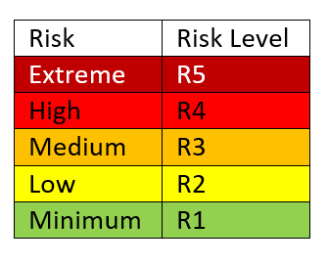Table 6: Risk Assessment of procedures

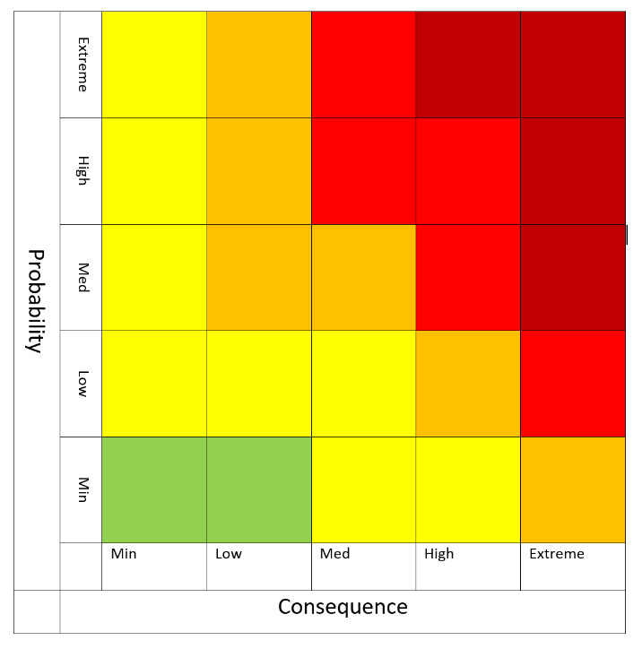

Table 6b: Mitigation summary

|  |  |  |  |  |
| --- | --- | --- | --- | --- |
| Process | Hazard | R-M* | Mitigation | R+M** |
| Handling of *C. neoformans* | Laboratory associated infection | R1 | * Category 2 pathogen * Biosafety level 1 * Standard microbiological practices * The Wallace lab has risk assessment in place, including biosafety and genetic modification | R1 |
| Cell culture | Contamination during inoculation, incubation and harvesting | R2 | * Use aseptic technique * Use sterile equipment * Use sterile flask stoppers * Use sterile reagents | R1 |
| Lyophilisation of cells | Contamination | R4 | * Carried out within a vacuum at -80⁰C * Use sterile equipment | R1 |
| Reagents used for RNA extraction | Contamination | R2 | * All reagents are part of a kit validated by the manufacturer * Use RNA handling techniques such as gloves and RNase free diluents and Eppendorf’s | R1 |
| Normalisation of RNA  extraction | Inter- and intra-sample variation | R5 | * Spike in a 1:100 ratio of methanol-fixed *Schizosaccaromyces pombe,* using three reference genes. | R1 |
| Quality and integrity of extracted RNA | Contamination and/or degradation | R5 | * ʎ 260/280 = 1.8-2 (contaminating protein) * ʎ 260/230 = 1.8-2 (contaminating salts) * Assess ribosomal RNA (rRNA) using gel electrophoresis | R1 |
| Removal of genomic DNA from RNA samples | Contaminating genomic DNA | R3 | * DNase treat samples * Check quality using nanodrop ʎ260/280 ratio and Agilent bioanalyzer | R1 |
| cDNA Synthesis for RT-qPCR | Contamination with PCR artefacts | R3 | * Run 3 biological replicates * Determine whether the same sequences are observed in each * Use appropriate controls; no template and no RT enzyme | R1 |
| Primer design for RT-qPCR | Ensure specificity | R3 | * All the primers to be used have been developed and validated in the Wallace labs to show specificity | R1 |
| Reagents for RT-qPCR | Contamination | R3 | * All reagents are part of a kit validated by the manufacturer * Use RNA handling techniques such as gloves and RNase free diluents * Use RNase free Eppendorf’s * Use appropriate controls; no template | R1 |
| Normalisation of RT-qPCR for data analysis | Misrepresentation of expression profiles obtained | R3 | * Select 3-4 stably expressed reference controls * Use the mean to normalise differences in the amount and quality of starting material * Use the mean to normalise the efficiency of the reaction * RT-qPCR will be carried out under MIQE guidelines | R1 |
| Enrich mRNA for RNA-seq | Remove rRNA (80% of RNA will be ribosomal) | R3 | * Select for mRNA with oligo-dT- hybridisation * Specific removal of rRNA | R1 |
| Library construction for RNA-seq | Contamination with PCR artefacts | R3 | * Run 3 biological replicates * Determine whether the same sequences are observed in each * Use appropriate controls; no template and no RT enzyme | R1 |
| Gene editing with CRISPR-Cas9 system | Specificity and efficiency | R4 | * Use short guide RNA (sgRNA) design software * Using RNA-seq data carefully select target sites * Carefully consider the sgRNA:Cas9 concentration * Optimize the delivery method (electroporation) | R1 |
| Training | Ineffective training | R3 | * See re-training program * Discuss progression of training with sponsor * Implement new training strategies where applicable | R1 |
| Equipment | Failures | R5 | * All equipment is maintained to a high standard within the Wallace labs by the lab manager | R1 |
| Timelines | Failure to complete the project | R5 | * Implement good time management and organisational strategy (see Timetable) * Review progress every 6 months with supervisor * Compile yearly reports | R1 |

*R-M: Risk without mitigation **R+M: Risk with mitigation

The key elements of mitigation are:

* Implementing good time management
* Organisational strategies
* Monthly and yearly reviews/reports
* Adherence to the proposed training schedule
* Good laboratory practice

These will ensure that this project is carried out to a high standard and will be completed within the timeframe given.

**Impact:**

This research is discovery driven and will advance knowledge regarding the fundamental biology of *Cryptococcus* and the initial stages of Cryptococcal infection in the lung. Functional profiling under differing stimuli may identify enriched pathways and/or micro-evolutionary adaptations during the early phase of *C. neoformans* infection and pave the way for the development of novel methods to abrogate the infection and dissemination of this fungus. I expect this fellowship to lead to 2 peer reviewed papers (MBio, mSphere, PLOS Genetics or PLOS Pathogens), 1 as first author. This research will be presented at conferences and seminars in order to engage the wider community and forge future collaborations.

**Further work:**

Using preliminary data produced during my fellowship I would like to investigate the possible relationship between fungi and bacteria in the microbiome to see if production of virulence factors in fungi are regulated or in some way modified by interactions with bacteria. Is there a conserved regulatory/signaling pathway that can induce the production of virulence factors in fungi? Investigation of how interactions of organisms in the microbiome contribute to disease; through bi-microbial cultures, investigation of cell wall components and the effects of small signal peptides produced by microbes,could provideimportant insights into novel pathways for the development of anti-fungal drugs. It is my intention to build on the experience I gain during this fellowship to develop a research strategy and collaborations that will follow on from this opportunity.

Word count: 2417/2250

**8. Ethical approval and licenses**

This work is covered by the School of Biological Sciences' ethics assessment ewallac2-0002, "Dynamic RNA processing in adapting fungi". The proposed work will be entirely with model fungi grown in liquid or solid media in laboratory conditions. No work will be conducted with patients, nor with animals, nor with animal/human tissue. There will be no contact with clinical data. *Cryptococcus neoformans* is a category 2 pathogen and the Wallace lab has all risk assessments in place, including biosafety and genetic modification, for the proposed work.

**9. Timetable** Table 7:Proposed Research and Re-training

|  |  |  |  |  |  |  |  |  |  |  |  |  |  |  |  |  |  |  |  |
| --- | --- | --- | --- | --- | --- | --- | --- | --- | --- | --- | --- | --- | --- | --- | --- | --- | --- | --- | --- |
| Aim | Task | Month | | | | | | | | | | | | | | | | | |
|  |  | 2 | 4 | 6 | 8 | 10 | 12 | 14 | 16 | 18 | 20 | 22 | 24 | 26 | 28 | 30 | 32 | 34 | 36 |
| Aim 1 | Experimental Design |  |  |  |  |  |  |  |  |  |  |  |  |  |  |  |  |  |  |
|  | Culture fungi/Microscopy |  |  |  |  |  |  |  |  |  |  |  |  |  |  |  |  |  |  |
|  | RNA extraction from fungi |  |  |  |  |  |  |  |  |  |  |  |  |  |  |  |  |  |  |
|  | Culture cells/morphology |  |  |  |  |  |  |  |  |  |  |  |  |  |  |  |  |  |  |
|  | RNA extraction |  |  |  |  |  |  |  |  |  |  |  |  |  |  |  |  |  |  |
|  | RT-qPCR/Automatic loading |  |  |  |  |  |  |  |  |  |  |  |  |  |  |  |  |  |  |
|  | R programming |  |  |  |  |  |  |  |  |  |  |  |  |  |  |  |  |  |  |
|  | Data analysis for RT-qPCR |  |  |  |  |  |  |  |  |  |  |  |  |  |  |  |  |  |  |
| Aim 2 | Experimental Design |  |  |  |  |  |  |  |  |  |  |  |  |  |  |  |  |  |  |
|  | Culture cells/morphology |  |  |  |  |  |  |  |  |  |  |  |  |  |  |  |  |  |  |
|  | RNA extraction |  |  |  |  |  |  |  |  |  |  |  |  |  |  |  |  |  |  |
|  | RT-qPCR/Data Analysis |  |  |  |  |  |  |  |  |  |  |  |  |  |  |  |  |  |  |
|  | RNA-Seq/Data Analysis |  |  |  |  |  |  |  |  |  |  |  |  |  |  |  |  |  |  |
| Aim 3 | Experimental Design |  |  |  |  |  |  |  |  |  |  |  |  |  |  |  |  |  |  |
|  | CRISPR gene editing |  |  |  |  |  |  |  |  |  |  |  |  |  |  |  |  |  |  |
| Outputs | Courses and conferences* |  |  |  |  |  |  |  |  |  |  |  |  |  |  |  |  |  |  |
|  | Progress meetings/reports |  |  |  |  |  |  |  |  |  |  |  |  |  |  |  |  |  |  |
|  | Publication of work |  |  |  |  |  |  |  |  |  |  |  |  |  |  |  |  |  |  |
|  | Future Planning |  |  |  |  |  |  |  |  |  |  |  |  |  |  |  |  |  |  |

*Daphne Jackson Trust and IAD courses (to be arranged) and appropriate seminars and conferences to present my work

|  |  |
| --- | --- |
|  | Training/Re-training |
|  | Research |
|  | Progress Meetings |
|  | Annual Reports |

**10. References**

1. Hughes, E. S., Bell, J. E. & Simmonds, P. *J. Virol.* **71**, 1272–80 (1997).

2. Hughes, E. S., Bell, J. E. & Simmonds, P. *J. Gen. Virol.* **78**, 2871–2882 (1997).

3. Hughes, E. S., Shaw, K. M. & Ashley, R. H. *Infect. Immun.* **69**, 1671–1678 (2001).

4. Park, B. J. *et al.* *AIDS* **23**, 525–530 (2009).

5. Harrison, T. S. *AIDS* **23**, 531–532 (2009).

6. Rajasingham, R. *et al.* *Lancet. Infect. Dis.* **17**, 873–881 (2017).

7. May, R. C., Stone, N. R. H., Wiesner, D. L., Bicanic, T. & Nielsen, K. *Nat. Rev. Microbiol.* **14**, 106–17 (2016).

8. Ma, H. *et al.* *Proc. Natl. Acad. Sci. U. S. A.* **106**, 12980–5 (2009).

9. Byrnes, E. J., Marr, K. A. & Marr, K. A. *Curr. Infect. Dis. Rep.* **13**, 256–61 (2011).

10. Perfect, J. R. *FEMS Yeast Res.* **6**, 463–468 (2006).

11. Zaragoza, O., Fries, B. C. & Casadevall, A. *Infect. Immun.* **71**, 6155–64 (2003).

12. McKee, T. J. & Komarova, S. V. *Am. J. Physiol. - Cell Physiol.* **312**, C624–C626 (2017).

13. Berthois, Y., Katzenellenbogen, J. A. & Katzenellenbogen, B. S. *Proc. Natl. Acad. Sci. U. S. A.* **83**, 2496–500 (1986).

14. Welshons, W. V., Wolf, M. F., Murphy, C. S. & Jordan, V. C. *Mol. Cell. Endocrinol.* **57**, 169–178 (1988).

15. Butts, A. *et al.* *MBio* **5**, e00765-13 (2014).

16. Mohr, J. A., Long, H., McKown, B. A. & Muchmore, H. G. *Med. Mycol.* **10**, 171–172 (1972).

17. Dambuza, I. M. *et al.* *PLOS Pathog.* **14**, e1006978 (2018).

18. Bauernfeind, A. *et al.* *Infection* **15**, 270–277 (1987).

19. Nikawa, H. *et al.* *Oral Microbiol. Immunol.* **16**, 279–283 (2001).

20. Mayer, F. L. & Kronstad, J. W. *MBio* **8**, e01537-17 (2017).

21. Peleg, A. Y., Hogan, D. A. & Mylonakis, E. *Nat. Rev. Microbiol.* **8**, 340–349 (2010).

22. Saito, F. & Ikeda, R. *Med. Mycol.* **43**, 603–612 (2005).

23. Ikeda, R. *et al.* *J. Bacteriol.* **189**, 4815–26 (2007).

24. Xu, X.-L. *et al.* *Cell Host Microbe* **4**, 28–39 (2008).

25. Barret, M. *et al.* *New Phytol.* **181**, 435–447 (2009).

26. Hogan, D. A. & Kolter, R. *Science* **296**, 2229–32 (2002).

27. Peterson, S. B., Dunn, A. K., Klimowicz, A. K. & Handelsman, J. *Appl. Environ. Microbiol.* **72**, 5421–7 (2006).

28. Cloud-Hansen, K. A. *et al.* *Nat. Rev. Microbiol.* **4**, 710–716 (2006).

29. Chun, C. D. & Madhani, H. D. *Methods Enzymol.* (2010). doi:10.1016/S0076-6879(10)70033-1

30. Wang, Y. *et al.* *Sci. Rep.* **6**, 31145 (2016).

31. Arras, S. D. M. *et al.* (2016). doi:10.1371/journal.pone.0164322

32. Arras, S. D. M., Chitty, J. L., Blake, K. L., Schulz, B. L. & Fraser, J. A. *PLoS One* **10**, e0122916 (2015).

**11. Future Planning**

This fellowship will give me valuable exposure to the unique work environment and culture in research as well as the technical and soft skills needed to succeed in a research driven career. I will update technical skills such as cell culture, RNA extraction and manipulation and RT-qPCR and develop new skills to enable me to compete in today’s research marketplace. These include RNA-Seq, CRISPR, lab automation and bioinformatics; all of which will be invaluable following on from this fellowship. Having the opportunity to develop professional and personal skills throughout this fellowship is vital to build my confidence as a researcher and network with possible future employers and/or collaborators. I will build my CV and boost my research and publication portfolio while working alongside world class researchers at the University of Edinburgh.

By the end of the fellowship I would like to produce good publications and build up my scientific profile by participating in conferences, attending seminars and workshops. My children will be 16 and 19 years and as such I will be looking for full time positions at this stage.

Plan A: Following this fellowship my first choice would be to write a project grant as researcher co-investigator (BBSRC, MRC, Springboard Award, Wellcome trust, Leverhulme early career fellowship) with Dr. Wallace to continue my research in *C. neoformans* at the University of Edinburgh.

Plan B: If I am unsuccessful securing funding to continue my research at the University of Edinburgh I will look for full time PDRA positions in an academic/research setting in central Scotland as my son will still be attending school in Lanark at this time (see Table 8a below). Within the University of Edinburgh there are three labs, including the Wallace labs, working on Cryptococcus; The Bayne Lab, Dr. E Bayne is my second supervisor, and The Hardwick lab. On completion of my fellowship it is possible a post-doctoral position may be available in one of these labs.

Table 8a: Plan B

|  |  |  |
| --- | --- | --- |
| Institute | Group | Research Interests |
| University of Edinburgh | Bayne Lab | RNA directed chromatin modification and endogenous RNAi pathways in Cryptococcus |
| Hardwick Lab | Cryptococcus cell division and aneuploidy in host relevant stress conditions |
| Amy Buck | Small RNAs in host-pathogen systems |
| Alex Rowe | Virulence factors of the malaria parasite and susceptibility in the host |
| Roslin Institute | Digard Lab | Viral factors controlling the replication/pathogenesis and spread of Influenza A virus |
| Prof B. Dutia | Molecular pathogenies of herpes virus and Influenza virus infections |
| Abigail Dick | Human and animal prion disease pathogenesis and strain characterization |
| Neil Mabbott | Molecular mechanisms underlying the pathogenesis of infectious and neurological diseases of ruminant livestock |
| Glasgow University | Mclauchlan Group | The functions of virus and host components during Hepatitis C infection |
| Thomson Group | Investigating the mechanism behind spontaneous clearance in order to advance the search for a vaccine using next generation sequencing |
| Hutchinson Group | Molecular biology of Influenza viruses and the interactions of viral and host proteins during infection |
| Dr. R Davies | Molecular interactions between bacterial pathogens and their host outer membrane proteins |

Plan C: My long term goal is to remain in research, however, if this is not feasible I will look to industry/biotechnology companies within central Scotland. (See Table 8b below).

Table 8b: Plan C

|  |  |  |
| --- | --- | --- |
| Area/Science Park | Company | Interest |
| Glasgow | Merck Life Sciences | Biosafety testing |
| Edinburgh | Mordun Research Institute | Proteomics facility |
| Roslin | Ingenza | Biotechnology |
| Penicuik | Ab Biotechnology Ltd Services | Product/process development and manufacturing |
| Elvingston science centre | Charles River Laboratories Ltd | Multi-National Pharmaceuticals Company |
| Pentlands Science Park | BioReliance Ltd | R&D and testing of high-technology pharmaceutical products |
| Moredun Research Institute | Government-supported animal disease research establishment |
| Moredun Scientific Ltd | Contract R&D company |
| Roslin Biocentre | Censo Biotechnologies Ltd | Stem cell technology, contract research services for drug discovery, toxicity testing and cell banking |
| Stirling University Innovation Park | Symbiosis Pharmaceutical Services | Drug product testing |
| Medpace | Biosafety testing |

With the experience I will gain throughout this fellowship I believe I will become a highly desirable candidate for future employment due to the high quality and world class resources available to me at the University of Edinburgh.

Word count: 389/400